7th September 2026

Tackling Butterfly Valve Leaks and Corrosion at a Water Treatment Works
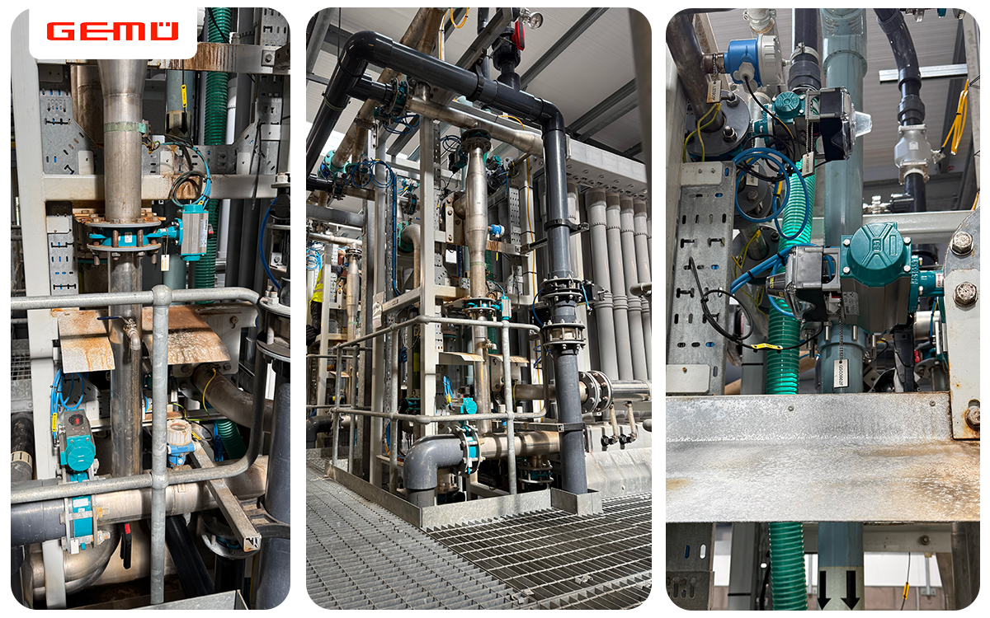
GEMÜ D481 pneumatically operated butterfly valves installed at the UF membrane plant.

Customer Testimonial
“GEMÜ valves consistently demonstrated superior reliability, lower maintenance demands, and improved overall performance compared with other products previously used in these systems." — Membrane Manager at the Water Treatment Works

GEMÜ Great Britain helped eliminate persistent leaks, corrosion and high operating torques affecting butterfly valves within an ultrafiltration (UF) membrane plant. Following a detailed site assessment, GEMÜ identified the root causes and supplied the D480 butterfly valve series, delivering improved reliability, reduced maintenance requirements and enhanced long-term performance, backed by ongoing technical support.

The Challenge
GEMÜ Great Britain supported a large water treatment works in addressing prolonged downtime caused by valve failures within its ultrafiltration (UF) membrane plant. The site, which produces up to 8.5 megalitres of drinking water each day, had been experiencing recurring failures with installed butterfly valves from another manufacturer, resulting in increased maintenance requirements and unplanned downtime.

The primary issues included:
- Leakage and reliability concerns impacting plant operation.
- Contamination leading to actuator failures.
- Corrosion and liner deterioration.
- Excessive operating torque.
- Increased health and safety risks for maintenance personnel.

The Investigation
GEMÜ Great Britain carried out a detailed site survey with the operations and maintenance teams to identify the root causes of the failures. The investigation found that the existing butterfly valves were over-specified and featured an unsuitable seal design, resulting in high operating torques and leakage. Material compatibility was another issue, with nylon-lined discs and EPDM liners unsuitable for the site’s CIP chemicals, contributing to corrosion and premature deterioration. The loose liners were also displaced under vacuum conditions, leaving them vulnerable to damage. The investigation reinforced the importance of understanding each individual application before specifying a valve solution.

The Solution
Following the site assessment, GEMÜ recommended the D480 butterfly valve series, selected to suit the application’s operating and vacuum conditions.

The supplied solution included:
- A suitable seal design for the application to improve sealing integrity and minimise leakage.
- Undercut discs, reducing operating torque and allowing smaller, lighter actuators.
- An integrated leak channel to protect pneumatic actuators.
- Stainless steel discs combined with WRAS-approved EPDM liners for improved corrosion resistance and potable water compliance.
- Bonded liners designed to withstand repeated vacuum conditions.
- Ongoing technical support throughout installation and commissioning.

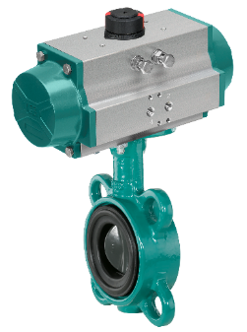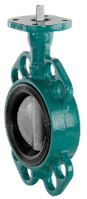
GEMÜ D481 pneumatically operated butterfly valve with bonded liner.

Conclusion

At GEMÜ, providing expert advice and taking the time to understand each application and priorities are central to how we work. By combining application expertise, detailed site assessments and correctly specified valve technology, GEMÜ helped the site eliminate recurring reliability issues and improve the long-term performance of its UF membrane plant.

